Unit 7 – Lesson 4. Hidden Markov Model (HMM)

Aim: What is Hidden Markov Model?

Objectives: After the lesson, students should be able to:
- Obtain understanding of Hidden Markov property and HMM
- Explain Hidden Markov chain using examples

References:
- CMU, Machine Learning

CLASS PROCEDURE:
Do Now:
What is a Markov Chain? What are the consumptions of Markov Model? Can you give an example?

Class Discussion / Presentation:
- What is a Hidden Markov Model?

- A hidden Markov model (HMM) is a statistical Markov model in which the system being modeled is assumed to be a Markov process with unobserved (hidden) states. (Source: wiki)

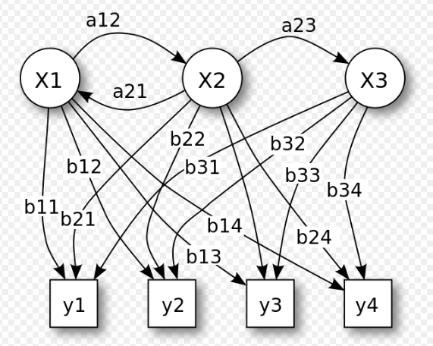

Figure 1. Probabilistic parameters of a hidden Markov model (example) X — states y — possible observations a — state transition probabilities b — output probabilities

- Comparing Markov Model and Hidden Markov Model.

- Markov Model:

- Assumption:

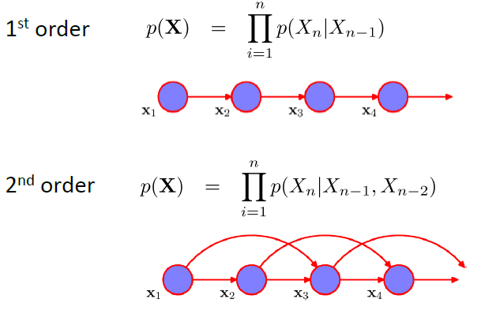

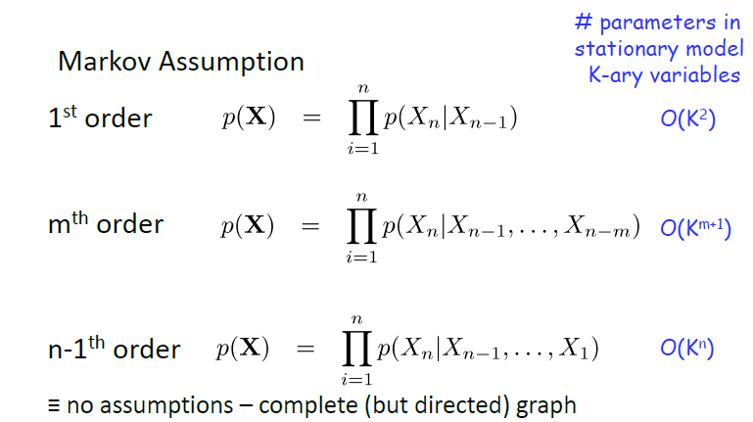

- Hidden Markov:
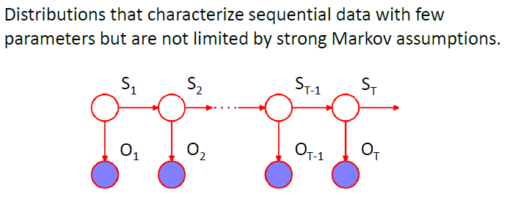

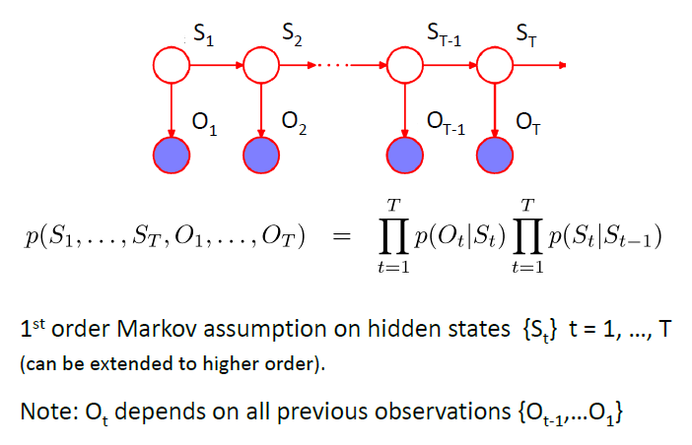

Pair – sharing Activity:

